
Crowdfunding Platform for Social Causes and Startups


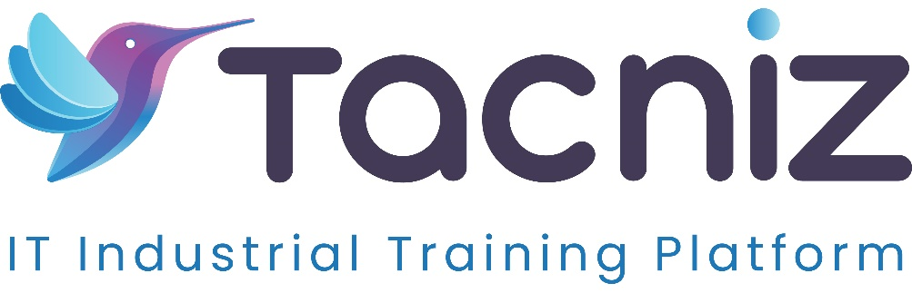

Problem Statement
Individuals, entrepreneurs, and nonprofits often face challenges in securing funds for projects, causes, or startup ideas. Traditional fundraising methods can be limited and may not reach a broad audience. Additionally, transparency and trust are crucial for backers who want assurance that their contributions are used as promised. A Crowdfunding Platform tailored for social causes and startups addresses these issues by providing a user-friendly, transparent platform where campaigns can easily raise funds. This platform empowers fundraisers by connecting them directly with supporters, enhancing trust and visibility, and enabling backers to support initiatives with confidence.

Project Type
- Type: Web and Mobile Application
- Category: Crowdfunding, Social Impact, Startup Funding

Industry Area
- Industry: FinTech, Social Good, Startup Ecosystem
- Relevant Sectors: Fundraising, Social Entrepreneurship, Financial Technology, Startup Support, Nonprofit Development

Software Expertise Required
To develop a secure, user-friendly crowdfunding platform, expertise in the following areas is essential:
- Frontend Development: Proficiency in web frameworks like React or Angular for web applications, and React Native or Flutter for mobile applications, to create a visually appealing and intuitive user interface for browsing campaigns, making donations, and tracking progress.
- Backend Development: Experience with Node.js, Django, or Ruby on Rails to manage user authentication, campaign creation, transaction processing, and secure storage of campaign data.
- Database Management: Expertise in databases like MySQL, PostgreSQL, or MongoDB to store campaign information, user profiles, donation records, and comments, ensuring data integrity and quick retrieval.
- Payment Integration: Knowledge of payment gateways like Stripe, PayPal, or Plaid to enable secure donations and offer a variety of payment options for backers.
- Blockchain for Transparency (Optional): For additional transparency, blockchain technology can be used to track and verify funds in real-time, ensuring that backers have visibility into fund usage.
- Notifications and Updates: Implementation of push notifications, email, and SMS alerts to keep backers informed about campaign milestones, updates, and achievements.
- Data Security and Compliance: Advanced knowledge of security practices and compliance standards, especially for handling sensitive financial information, ensuring that donor and campaign data is protected.

Use Cases
- For Individuals and Entrepreneurs: Users can create campaigns to fund personal projects or startup ideas, attracting a wide range of supporters who resonate with their vision.
- For Nonprofits and Social Causes: Nonprofit organizations can raise funds for social causes, ensuring transparency in fund usage and fostering trust with their supporters.
- For Backers and Donors: Backers can browse through campaigns, make secure donations, and track the progress of projects they support, ensuring that their contributions make a tangible impact.
- For Corporate Social Responsibility (CSR) Programs: Companies can use the platform to support causes aligned with their CSR initiatives, promoting social responsibility and strengthening community relationships.

Expected Outcomes
The platform will provide a seamless, engaging crowdfunding experience, where individuals, nonprofits, and startups can raise funds transparently. By offering real-time updates and ensuring secure transactions, the platform builds trust among backers and enhances engagement with supported causes. The outcome is a community-focused crowdfunding solution that helps users meet their funding needs while fostering accountability and transparency.

Benefits
- Empowers Fundraisers: Provides a streamlined, accessible platform for raising funds, allowing entrepreneurs and nonprofits to focus on their project goals.
- Enhanced Transparency for Backers: Real-time updates and a clear view of how funds are used build trust, encouraging backers to contribute and support more campaigns.
- Increased Community Engagement: Backers can follow the progress of campaigns they support, interact with project creators, and celebrate project milestones, creating a sense of community and shared purpose.
- Diverse Funding Opportunities: Offers an alternative to traditional fundraising, enabling more people to bring their ideas to life without depending on banks or venture capital.
- Cost-Effective Fundraising Solution: For nonprofits, this platform offers an affordable way to raise funds with minimal overhead, helping them focus on impact rather than fundraising logistics.
- Global Reach: The platform allows fundraisers to reach potential backers worldwide, expanding their support network and increasing funding possibilities.

Project Duration
Estimated Duration: 5-6 months for development, testing, and deployment of a fully functional platform, with additional time for payment integration, security testing, and user experience optimization.

